How to Access Your Financial Aid Information


Go to the Patrick & Henry Community College website: www.patrickhenry.edu
- Click on at the top of the page.
- Enter your P&HCC username and password and click “SIGN IN”.
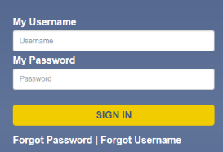
Use the links under the Sign in bar if you have forgotten your password or username.
If you have further problems, you can contact support@patrickhenry.edu or call 276-656-0308 or
276-656-0235

- Next, click on “SIS”
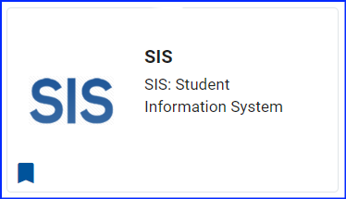

- Finally, click on “Student Center”
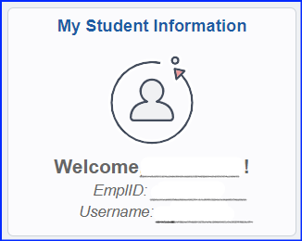
Your Name
abc#####
#######

- To-Do List items will appear on the right-hand side of the screen in bold. Once an item has been completed, the bold will be removed.



- Under the Finances area of the Student Center click on “View Financial Aid’ to see your aid award and click on “Account Inquiry” to determine if you may owe additional funds.
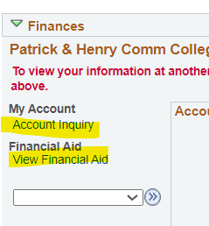

**All Financial Aid Correspondence Will Be Sent
Via Your Message Center Or
Your Student Email Address**

