JobsEQ Logo

Industry Spotlight



Other Services (except Public Administration)

Patrick & Henry Community College

cea_image_logo

cea_image_nologo



[Industry Snapshot 4](#_Toc177136143)

[Staffing Pattern 5](#_Toc177136144)

[Geographic Distribution 6](#_Toc177136145)

[Employment Distribution by Type 7](#_Toc177136146)

[Sector Strategy Pathways 8](#_Toc177136147)

[Postsecondary Programs Linked to Other Services (except Public Administration) 9](#_Toc177136148)

[Region Definition 10](#_Toc177136149)

[FAQ 11](#_Toc177136150)

Other Services (except Public Administration)  
Patrick & Henry Community College – 2024Q1

|  |  |  |  |  |
| --- | --- | --- | --- | --- |
| Employment  cea_image_emplChart  2,287  Regional employment / **6,967,932** in the nation | |  | Wages  cea_image_wageChart  $27,371  Avg Wages per Worker / **$43,307** in the nation | |
| -0.6%🡻  Avg Ann % Change Last 10 Years / **+0.3%** in the US  cea_image_changeEmpl | 4.7%  % of Total Employment / **4.2%** in the US  cea_image_pctEmpl |  | 3.9%🡹  Avg Ann % Change Last 10 Years / **+4.2%** in the US  cea_image_changeWage |  |

Top Occupation Groups

cea_image_staffPatternChart

# Industry Snapshot

|  |  |  |
| --- | --- | --- |
| Employment  cea_image_emplChart |  | Wages  cea_image_wageChart |

| **2-Digit Industry** | **Empl** | **Avg Ann Wages** | **LQ** | **5yr History** | **Annual Demand** | **Forecast Ann Growth** |
| --- | --- | --- | --- | --- | --- | --- |
| **Other Services (except Public Administration)** | **2,287** | **$27,371** | **1.11** |  | **254** | **-0.3%** |

|  |  |  |
| --- | --- | --- |
|  |  | Employment is one of the broadest and most timely measures of a region’s economy. Fluctuations in the number of jobs shed light on the health of an industry. A growing employment base creates more opportunities for regional residents and helps a region grow its population. |
|  |  | Since wages and salaries generally compose the majority of a household’s income, the annual average wages of a region affect its average household income, housing market, quality of life, and other socioeconomic indicators. |

# Staffing Pattern

cea_image_staffPatternChart

| **6-digit Occupation** | **Empl** | **Avg Ann Wages** | **Annual Demand** |
| --- | --- | --- | --- |
| Automotive Service Technicians and Mechanics | 122 | $42,500 | 10 |
| Hairdressers, Hairstylists, and Cosmetologists | 110 | $42,800 | 15 |
| Maids and Housekeeping Cleaners | 104 | $28,600 | 14 |
| Clergy | 103 | $52,900 | 8 |
| Directors, Religious Activities and Education | 91 | $47,500 | 8 |
| Childcare Workers | 89 | $28,200 | 14 |
| Office Clerks, General | 75 | $34,700 | 8 |
| General and Operations Managers | 70 | $93,300 | 5 |
| Secretaries and Administrative Assistants, Except Legal, Medical, and Executive | 57 | $39,300 | 5 |
| Cleaners of Vehicles and Equipment | 47 | $30,800 | 6 |
| Remaining Component Occupations | 1,374 | $54,300 | 155 |
| **Total** | **2,242** |  |  |

|  |  |  |
| --- | --- | --- |
|  |  | The mix of occupations points to the ability of a region to support an industry and its flexibility to adapt to future demand. Industry wages are a component of the cost of labor for regional employers. |
|  |  |  |

# Geographic Distribution

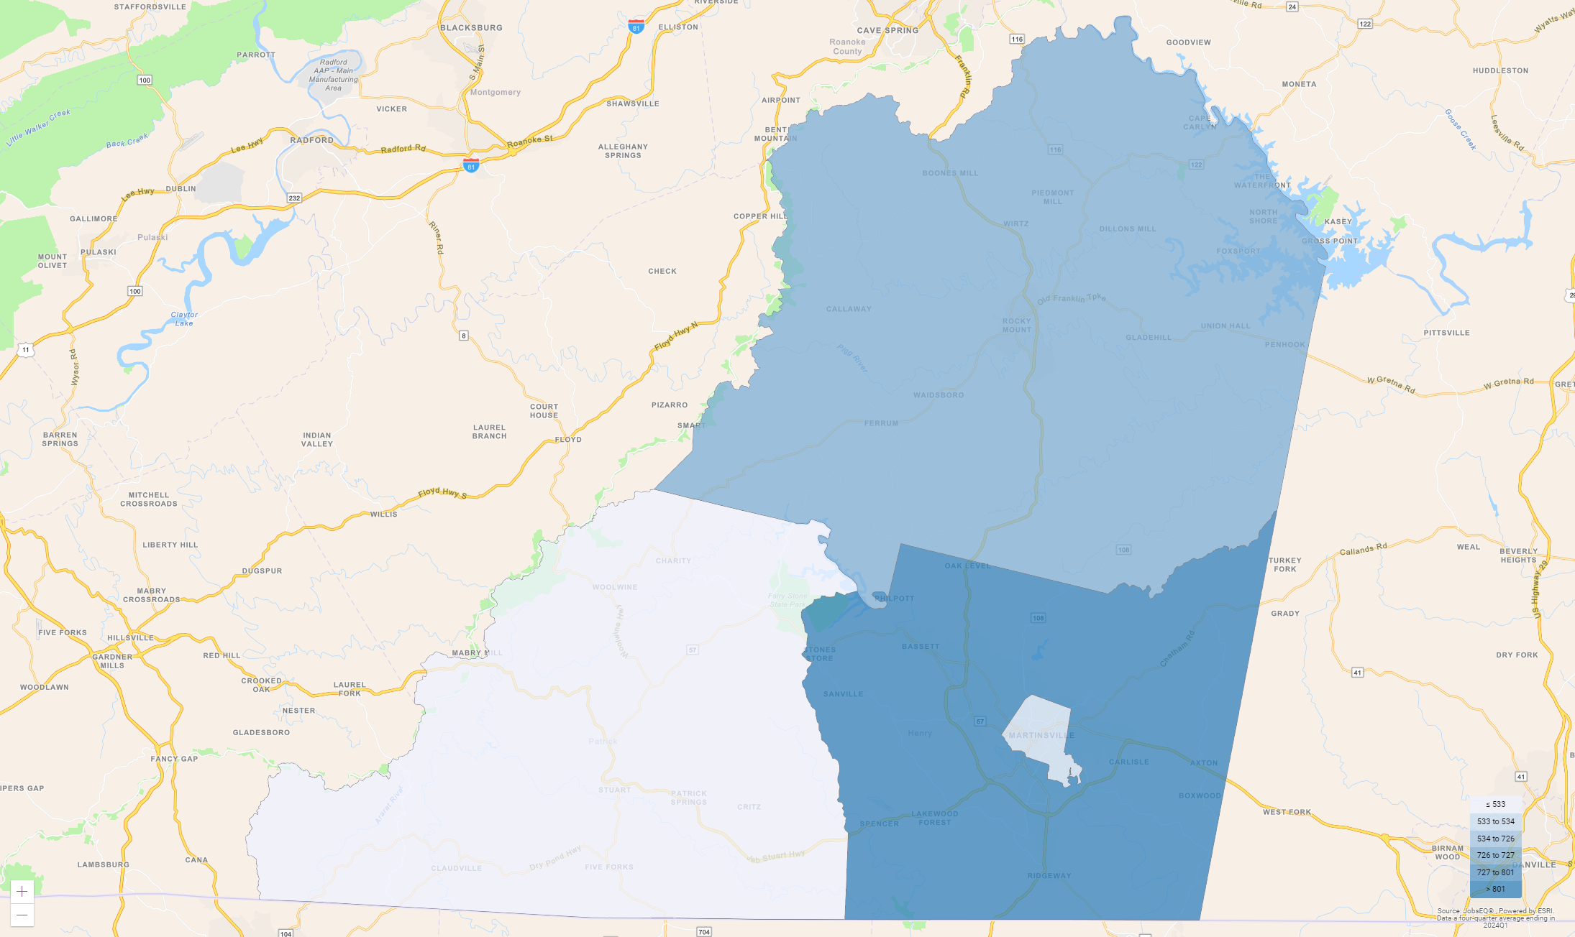

| **Region** | **Empl** |  | **Region** | **Empl** |
| --- | --- | --- | --- | --- |
| Henry County, Virginia | 801 |  | Martinsville City, Virginia | 534 |
| Franklin County, Virginia | 726 |  | Patrick County, Virginia | 226 |

Source: [JobsEQ®](http://www.chmuraecon.com/jobseq)

|  |  |  |
| --- | --- | --- |
|  |  | The geographic distribution of industry employment by place of work illustrates the impact on labor force demand and commuting patterns. |

# Employment Distribution by Type

The table below shows the employment mix by ownership type for Other Services (except Public Administration) for the Patrick & Henry Community College. Four of these ownership types — federal, state, and local government and the private sector — together constitute “Covered Employment” (employment covered by the Unemployment Insurance programs of the United States and reported via the Quarterly Census of Employment and Wages).

“Self-Employment” refers to unincorporated self-employment and represents workers whose primary job is self-employment (that is, these data do not include workers whose primary job is a wage-and-salary position that is  
supplemented with self-employment).

cea_image_distribution

|  |  | **Empl** | **%** |
| --- | --- | --- | --- |
|  | Private | 1,226 | 53.6% |
|  | Self-Employment | 375 | 16.4% |
|  | Local Government | 9 | 0.4% |
|  | Other Non-Covered | 677 | 29.6% |

Source: [JobsEQ®](http://www.chmuraecon.com/jobseq)

|  |  |  |
| --- | --- | --- |
|  |  | Strong entrepreneurial activity is indicative of growing industries. Using self-employment as a proxy for entrepreneurs, a higher share of self-employed individuals within a regional industry points to future growth. |

# Sector Strategy Pathways

cea_image_pathways

|  |  |  |
| --- | --- | --- |
|  |  | The graphics on this page illustrate relationships and potential movement (from left to right) between occupations that share similar skill sets. Developing career pathways as a strategy promotes industry employment growth and workforce engagement. |

# Postsecondary Programs Linked to Other Services (except Public Administration)

| **Program** | **Awards** |
| --- | --- |
| **Patrick & Henry Community College** | |
| Accounting and Related Services, Other | 4 |
| Automobile/Automotive Mechanics Technology/Technician | 10 |
| Business Operations Support and Secretarial Services, Other | 5 |
| Child Care Provider/Assistant | 19 |
| Criminal Justice/Law Enforcement Administration | 8 |
| Electrical, Electronic, and Communications Engineering Technology/Technician | 14 |
| Industrial Electronics Technology/Technician | 18 |
| Licensed Practical/Vocational Nurse Training | 9 |
| Registered Nursing/Registered Nurse | 21 |
| Welding Technology/Welder | 49 |

Source: [JobsEQ®](http://www.chmuraecon.com/jobseq)

|  |  |  |
| --- | --- | --- |
|  |  | The number of graduates from postsecondary programs in the region identifies the pipeline of future workers as well as the training capacity to support industry demand. |
|  |  | Among postsecondary programs at schools located in the Patrick & Henry Community College, the sampling above identifies those most linked to occupations relevant to Other Services (except Public Administration). For a complete list see JobsEQ®, <http://www.chmuraecon.com/jobseq> |

# Region Definition

| **Patrick & Henry Community College is defined as the following counties:** | | |
| --- | --- | --- |
| Franklin County, Virginia |  | Patrick County, Virginia |
| Henry County, Virginia |  | Martinsville City, Virginia |

# FAQ

What is (LQ) location quotient?

Location quotient is a measurement of concentration in comparison to the nation. An LQ of 1.00 indicates a region has the same concentration of an industry (or occupation) as the nation. An LQ of 2.00 would mean the region has twice the expected employment compared to the nation and an LQ of 0.50 would mean the region has half the expected employment in comparison to the nation.

What is annual demand?

Annual demand is a of the sum of the annual projected growth demand and separation demand. Separation demand is the number of jobs required due to separations—labor force exits (including retirements) and turnover resulting from workers moving from one occupation into another. Note that separation demand does not include all turnover—it does not include when workers stay in the same occupation but switch employers. Growth demand is the increase or decrease of jobs expected due to expansion or contraction of the overall number of jobs.

What is the difference between industry wages and occupation wages?

Industry wages and occupation wages are estimated via separate data sets, often the time periods being reported do not align, and wages are defined slightly differently in the two systems (for example, certain bonuses are included in the industry wages but not the occupation wages). It is therefore common that estimates of the average industry wages and average occupation wages in a region do not match exactly.