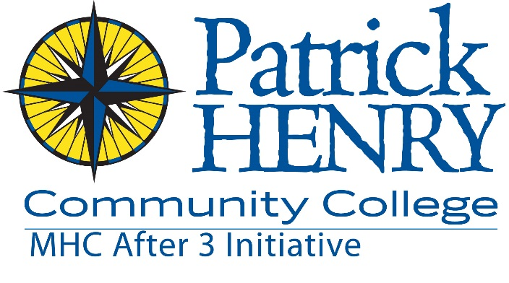
Application for Admission
Patrick Henry Community College
MHC After 3—High School
645 Patriot Ave. Martinsville, VA 24112
276-656-5489 mhcafter3@ph.vccs.edu

Student Name: _______________________________________________Cell #: ( )________________________
Mailing Address: __________________________________City: ________________State: _______Zip:__________
Email: ____________________________________________ Contact me: ________ Text ______Email _______Call

Birthdate:________________ Male______ Female_______ School : Current Grade:______

American Indian Hispanic Asian African American White ___Multi-Racial ___Other

Free or Reduced Lunch: Yes ______ No _______ Did Not Apply ______ T-shirt: Adult _____S ____M____L____XL
Student Interests

Are You Enrolled in Clubs at School or in the community? ______Yes _______ No ________No, but I’d like to be

Do you have any special needs of which staff need to be aware? __________________________________________________________________________________________________

Are you interested in attending college: Yes ________ No ________ Not Sure ___________

If you answered yes, where will you apply? _____________________________________________________________

I would like to pursue a career in: ______________________________________________________________________

Describe yourself in 10 words or less: __________________________________________________________________

___________________________________________________________________________________________________

What do you like about school: ________________________________________________________________________

___________________________________________________________________________________________________

What clubs/sports/activities do you participate in currently: _______________________________________________

__________________________________________________________________________________________________

What would you like to do?

___Sports ___Dancing ___College Exploration
___Music ___Leadership Skills ___ Outdoor activities/Hiking
___Painting ___Communication Skills ___Summer Camp
___Drama ___Engineering ___Trying new things
___Career Exploration ___Science ___Going new places & making friends
___Social/Cultural Activities ___Poetry/Creative Writing ___ _____________________________
___ Tutoring/ Homework Help

Guardian Information:

Parent/Guardian’s Name:__________________________________________ Cell #: ___________________________

Mailing Address: _____________________________ City: __________________ State: _______ Zip: ____________

Email: _______________________________________ Contact me by: _______Text _______Email ________Mail

Relationship to student: ________________________________ Send me information about family programs: ______

Parent/Guardian’s Name:__________________________________________ Cell #: ___________________________

Mailing Address: _____________________________ City: __________________ State: _______ Zip: ____________

Email: _______________________________________ Contact me by: _______Text _______Email ________Mail

Relationship to student: ________________________________ Send me information about family programs:______

Yes, my child has permission to participate in field trips, activities and events sponsored by MHC After 3.

Emergency Information:

1. Emergency Contact (not parent):__________________________________________ Cell #: ____________________

Relationship to student: ________________________________

2. Emergency Contact (not parent):__________________________________________ Cell #: ____________________

Relationship to student: ________________________________

Family Doctor or Clinic: ___________________________________________ Phone: ____________________________

Insurance Provider: ____________________________________ Policy Number: ______________________________

Please indicate allergies and medical conditions of your child _____________________________________________

_________________________________________________________________________________________________

List any medications your child is currently taking _____________________________________________________

_________________________________________________________________________________________________

I understand that the information I have provided here is for the use of MHC After 3-PHCC and partner agencies only and will remain confidential. I relieve the program of any responsibility for any accidents, illnesses, or injuries which may result from participation and allow them to take pictures for program use. I give my permission for MHC After 3 to review my/my child’s school records for the purposes of recording grades, reviewing test performance and reviewing school attendance rates.

Be it known that I, as parent/guardian of the named student, hereby grant unto any medical doctor or hospital my consent and authorization to provide such aid, treatment, or care to said student as, in judgment of the doctor or hospital, may be required on an emergency basis in the event said student should be injured or stricken ill while participating in an MHC After 3 sponsored event or field trip.
Parent's Signature________________________________________________Date___________________________

Student Signature ________________________________________________Date _________________________

