for ROAD Scholar members only
Meet the ROAD Scholar Staff

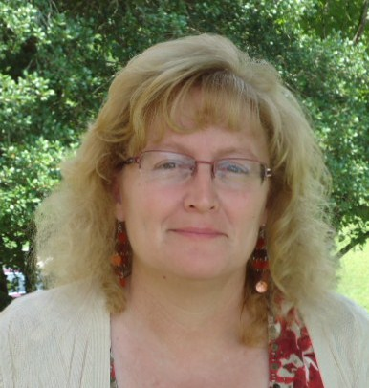
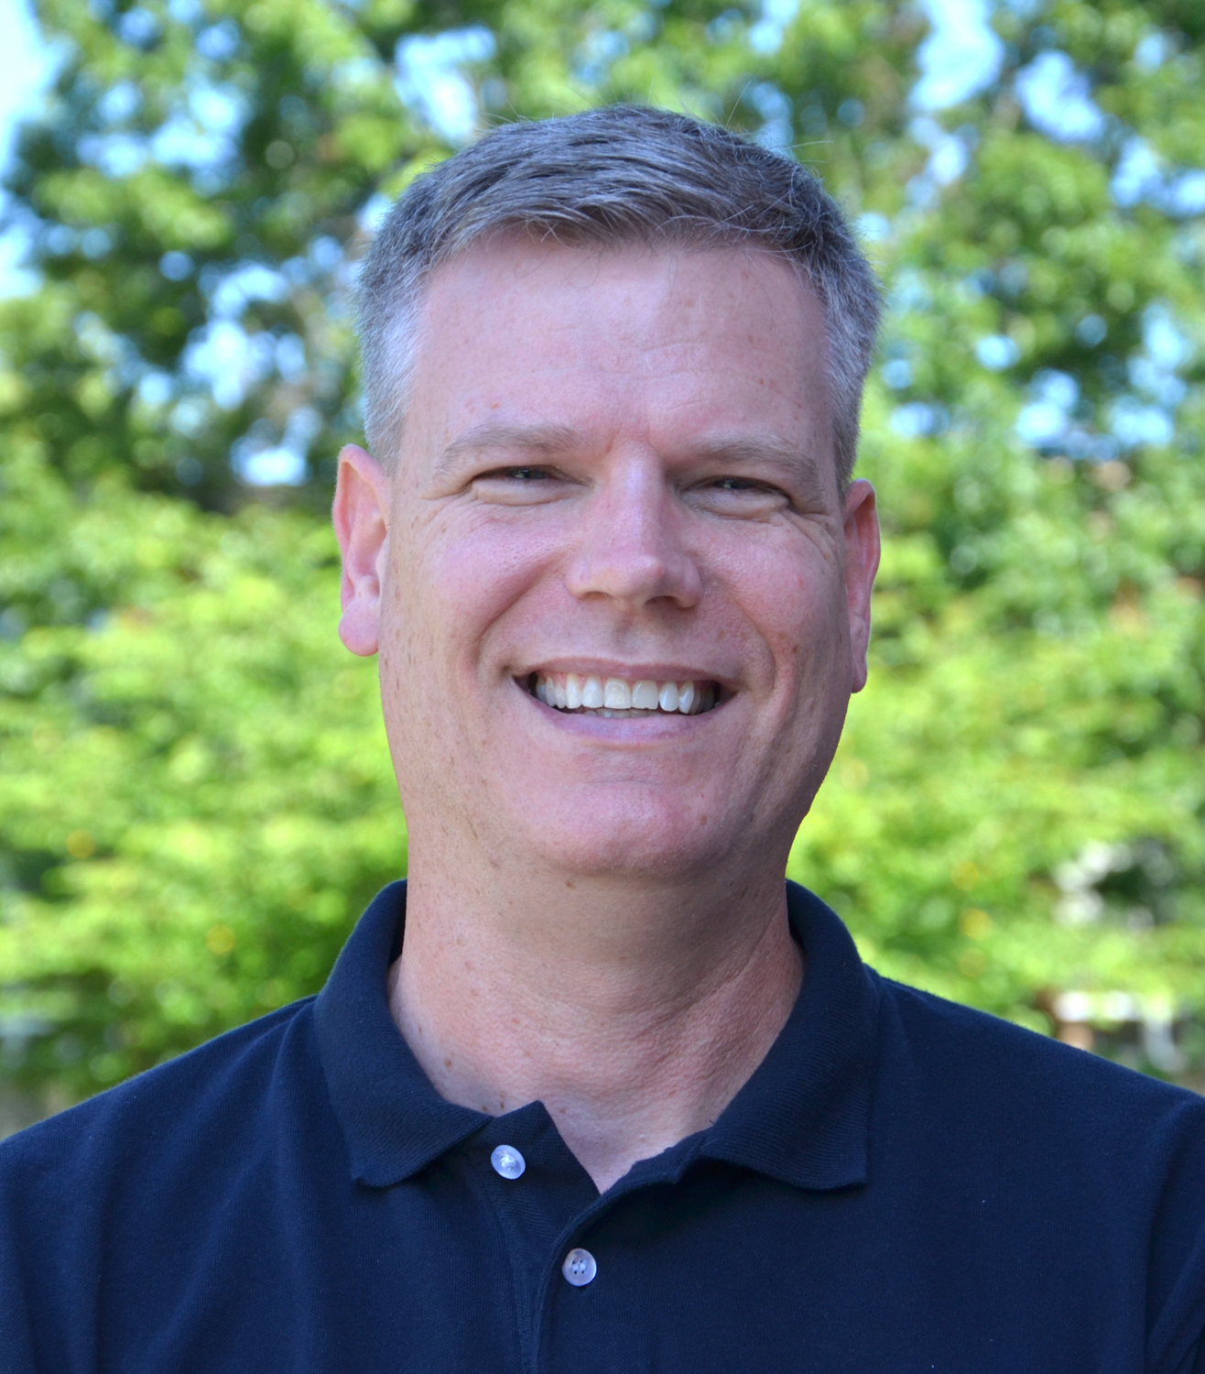
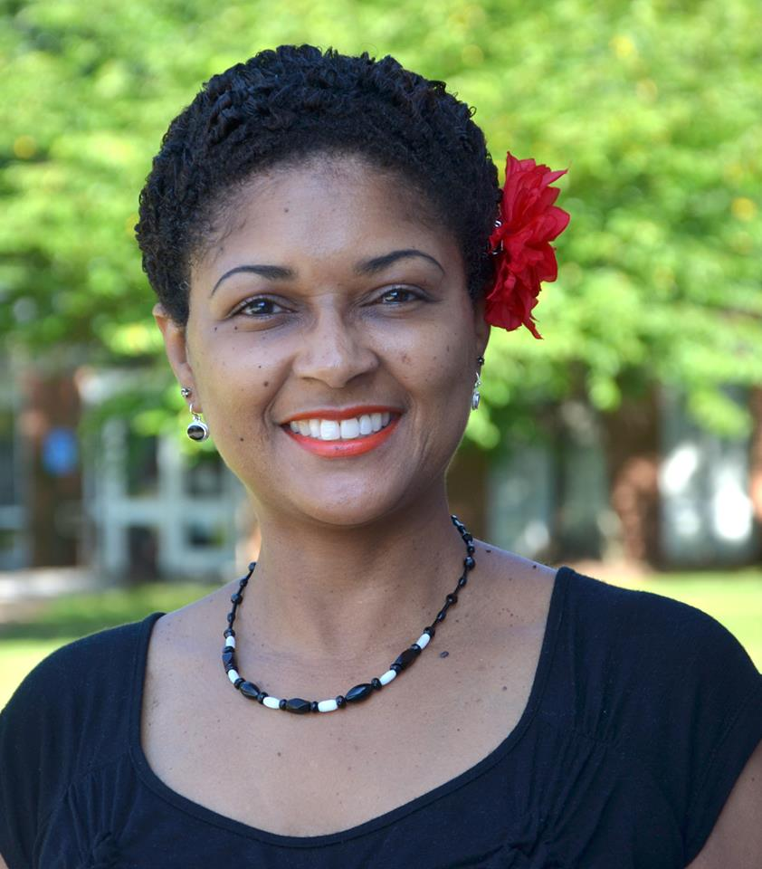
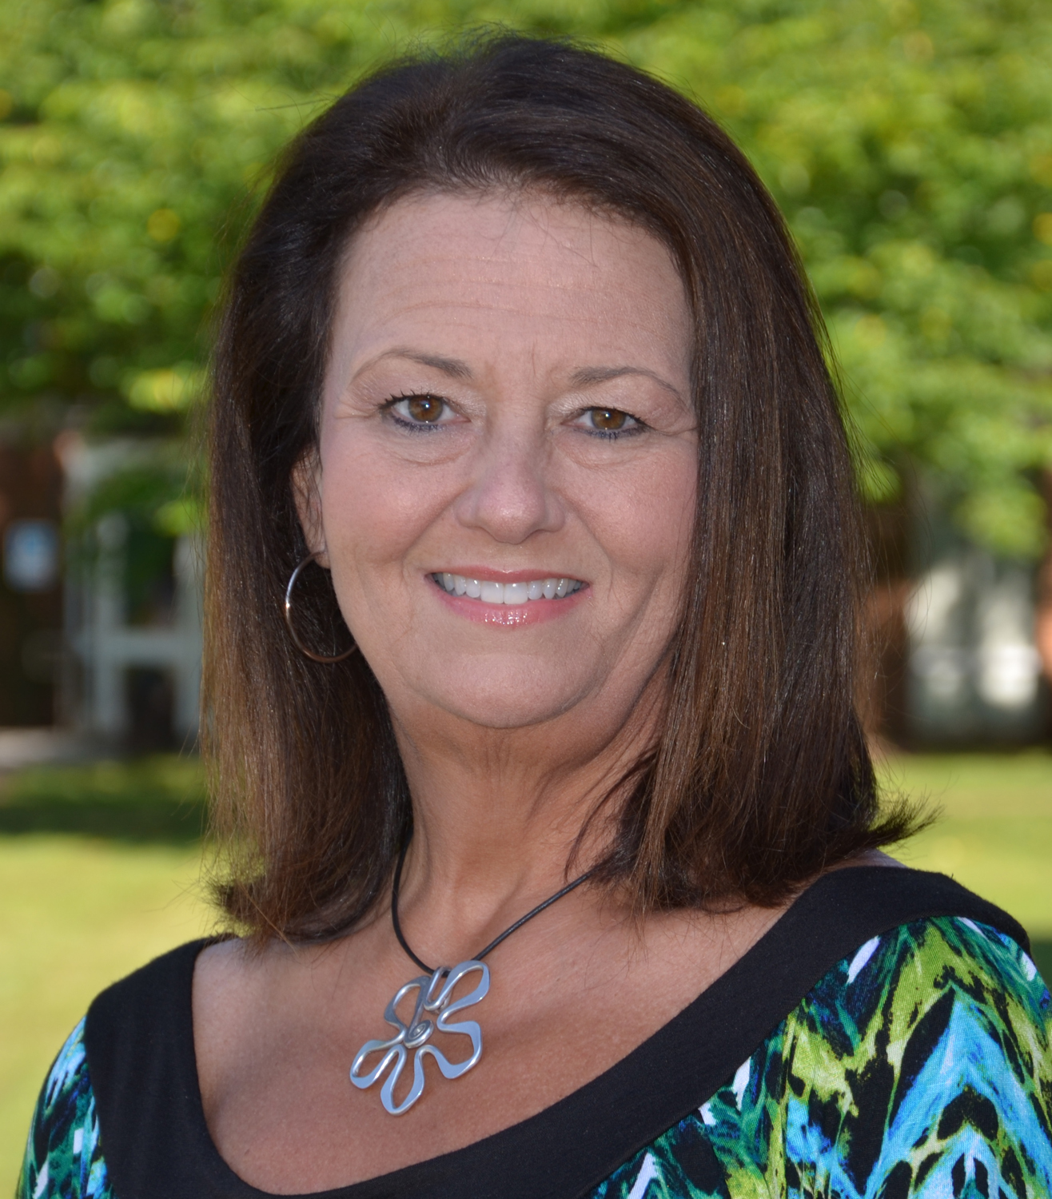
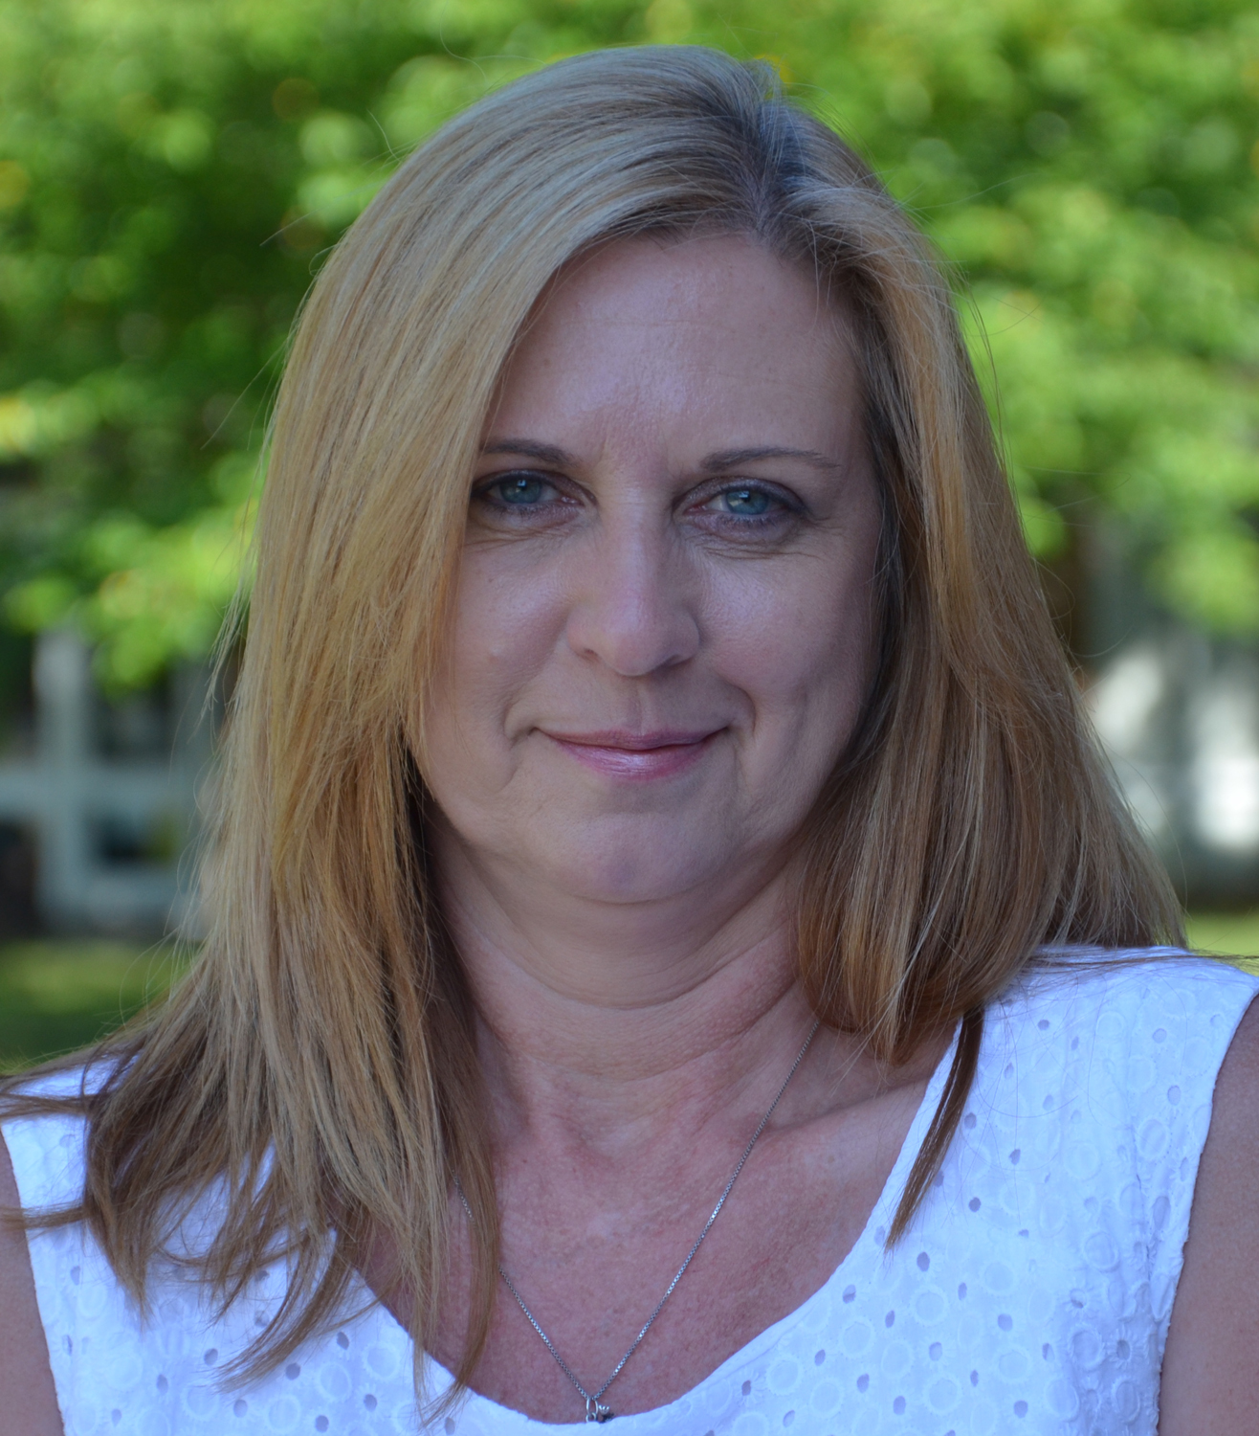
Dr. Patsy Anderson-Rusmisel
Director
LRC 109C; 276-656-0307
panderson-rusmisel@patrickhenry.edu

Counseling & Advising: ROAD Scholar Counselors will help you:
- register for classes
- apply for financial aid and scholarships
- explore career options
Scott Guebert
disAbility Counselor
LRC 109D; 276-656-0257
sguebert@patrickhenry.edu

- improve your study skills
- address personal or academic problems
Cultural & Social Activities
- FREE visits to educational, historic, and cultural sites
- FREE tickets to local events
Ophelia Griggs
Academic Counselor/Tutor Coordinator
LRC 109A; 276-656-0305
ogriggs@patrickhenry.edu

- one-day trips/activities
Equipment for Loan from Institution
Just for SSS Members…laptop computers
Supplemental Scholarships-Grant: extra money to help with expenses and emergencies
You…
Jennifer Hollyfield
Transfer Counselor
LRC 109B; 276-656-0306
jhollyfield@patrickhenry.edu
- MUST apply for financial aid
- complete application form
- are NOT guaranteed to receive the grant
Susan Plunk
Office Manager
LRC 109; 276-656-0296
splunk@patrickhenry.edu
Student Support Services (SSS): federally funded grant program of $318,050 per year (2015-16) through Title IV (TRIO) of the U.S. Department of Education.

- participate in required activities

Patrick Henry Community College does not discriminate on the basis of race, color, national origin, sex, or disability in its programs and activities. The following person has been designated to handle inquiries regarding the non-discrimination policy: Affirmative Action Coordinator, Francis T. West Hall, room 148, 276.656.0212.
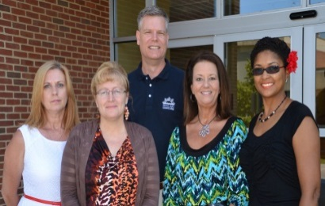
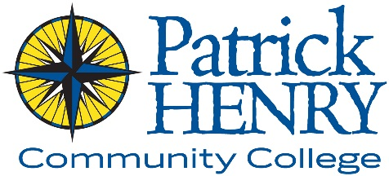
Reaching Out
&
Achieving the Dream
Be a ROAD Scholar
with
Student Support Services
From here, YOU can go anywhere!

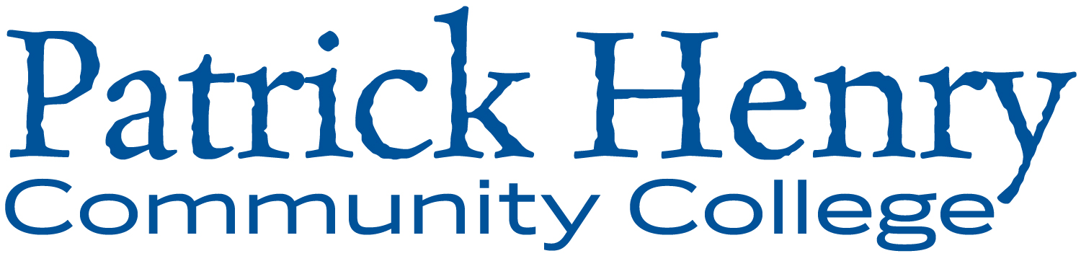

Patrick Henry Community College
645 Patriot Avenue
Martinsville, VA 24112
(276) 638-8777
www.patrickhenry.edu

How do I become a ROAD Scholar of Student Support Services?
Complete an application form and return it to the SSS office. Then schedule an appointment with a SSS counselor to:
- determine if you are eligible for SSS
- discuss your academic needs
- decide which services you need

How can I be eligible for the program?
You must be one or more of the following:
- first generation—your parent(s) did not graduate from a 4-year college
- low income—you are unemployed, don’t earn very much, or are receiving financial aid
- disability—you have a physical, medical, psychological, learning, or ADD/ADHD disability
AND
- You have an academic need for SSS services
- Maintain a 2.0 GPA
- Must complete your program within 4 years

Where is the ROAD Scholar Program?
Learning Resource Center – room 109
(276) 656-0296
1-800-232-7997 (toll free)
(276) 632-1034 (fax)
sss@patrickhenry.edu
What is the ROAD Scholar program of Student Support Services?
The ROAD Scholar Program of Student Support Services (SSS) is an exclusive program at PHCC that helps students be successful in college and achieve their educational goals.
How does being a ROAD Scholar help PHCC students?
SSS helps PHCC students by providing the following services and activities. Some of these services and activities are for ALL students at PHCC, and some are only for members of SSS.
for ALL Students
Academic Assistance & Tutoring
Math Lab – LRC 108
- help for any math class
- no appointment needed
Writing Center – LRC 104
- help with any writing assignment for any class
- appointments available
- “walk-in” help without an appointment for proofreading
Study Groups/Tutoring – LRC, 1st floor
- one-on-one and small group help for most subjects
- appointments available
Study Skills and Other Workshops
- Math Lab & Writing Center workshops (may earn extra credit)
- special presentations/topics
Computer Lab—LRC 1st floor: Lab assistants will help you…
- learn to use your PHCC e-mail, Blackboard, and Student Information System
- Information System
- use Microsoft Office for homework assignments
- use the Internet for research
Transfer Assistance: ROAD Scholar Transfer Counselor will help you:
- decide which 4-year college or university is best for you
- select the right classes at PHCC
- fill out admission and financial aid applications for 4-year schools
- take FREE trips to visit the campus of 4-year colleges and universities
Disability Services: FREE help to any student with a disability (physical, medical, psychological, learning, ADD/ADHD)
- confidential counseling & advising
- accommodations (i.e.: note-takers, extra time for tests, recorded or electronic books)
- assistive technology (i.e.: electronic dictionary, computer dictation software, scanning and reading software)
- professional disability advisors for individual help

Revised July 2015

