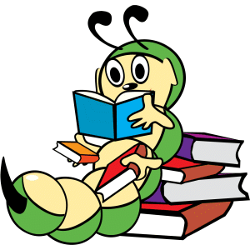

Open Book Test Taking Tips

Spend an equal or greater amount of time preparing as you would for a normal test. The open book test will most likely be harder than if it were a closed book exam.
Familiarize yourself with the book and relevant materials.
If it's allowed, write down all the important formulas and key information on a separate sheet so you don't have to search through your book for it.
Focus on learning the main ideas and get a feel for where they are located in the book, learn the details later if there's still time.
Highlight important points, use post-it notes, bookmarks and make notes in your book, if it is allowed.
Bring all the resources that your professor or teacher allows.
Answer the easy questions that you know off the top of your head first, then go back and answer the questions where you need to reference your book.
Use quotations from the book to support your view, but don't over-quote, be sure to give your own insight and commentary.

