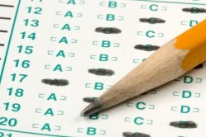
Multiple Choice Test Taking Tips
Tips on answering multiple choice questions:
Read the question before you look at the answer.
Come up with the answer in your head before looking at the possible answers, this way the choices given on the test won't throw you off or trick you.
Eliminate answers you know aren't right.
Read all the choices before choosing your answer.
If there is no guessing penalty, always take an educated guess and select an answer.
Don't keep on changing your answer, usually your first choice is the right one, unless you misread the question.
In "All of the above" and "None of the above" choices, if you are certain one of the statements is true don't choose "None of the above" or one of the statements are false don't choose "All of the above".
In a question with an "All of the above" choice, if you see that at least two correct statements, then "All of the above" is probably the answer.
A positive choice is more likely to be true than a negative one.
Usually the correct answer is the choice with the most information

