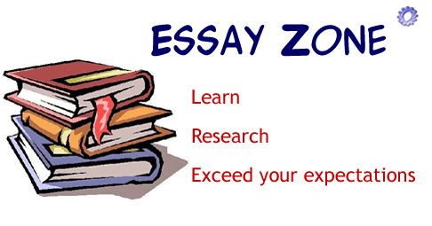

Essay Test Tips

Read the directions carefully. Pay close attention to whether you are supposed to answer all the essays or only a specified amount (e.g. "Answer 2 out of the 3 questions).
Make sure that you understand what the question is asking you. If you're not, ask your instructor.
Make sure that you write down everything that is asked of you and more. The more details and facts that you write down, the higher your grade is going to be.
Budget your time, don't spend the entire test time on one essay.
If the question is asking for facts, don't give your personal opinion on the topic.
When writing your essay, try to be as neat as possible, neater papers usually receive higher marks.
Make an outline before writing your essay. This way your essay will be more organized and fluid. If you happen to run out of time, most instructors will give you partial credit for the ideas that you have outlined.
Don't write long introductions and conclusions, the bulk of your time should be spent on answering the question(s) asked.
Focus on one main idea per a paragraph.
If you have time left at the end, proofread your work and correct any errors.
Budget your time. If you have an hour to write 3 essays, spend no more than 20 minutes on each essay, then if you have time left over at the end go back and finish any incomplete essays.
If you aren't sure about an exact date or number, use approximations e.g. "Approximately 5000" or "In the late 17th century."
If you make a mistake, simply draw a line through it, it is much neater and quicker than erasing it.

