Reading a Math Textbook - Remember that the best way to learn math is by doing.
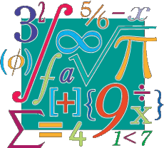
Reading a math textbook is different than reading other textbooks. Math textbooks alternate passages of explanation with mathematical formulas and example problems. Here are suggestions to help you gain the most understanding and mastery from your math textbooks.
- Slow your reading pace. Skimming does not work when reading a math textbook. You need to read the text word by word and sentence by sentence.

- Study any diagrams and other illustrations that are provided.
- Don't try to memorize everything. Read for understanding.
- Math has its own vocabulary. Keep a section in your notebook in which you write math terms and their meanings.
- Go back to an earlier part of the text when you don't understand something. Math is cumulative. If you come to something you don't understand, it may be because you didn't understand what came before it.
- When sample problems are presented, carefully read any explanations that are provided about to how to solve the problems.
- If you are unsure about the explanation that is provided for a problem, look for that type of problem and its solution in another math textbook. You can also use the Internet and YouTube videos for this purpose.
- When working out practice problems, start with the problems you find easiest and work your way up to the problems you find most difficult.
- After reading a problem and its solution, close the book and try to solve the problem on your own. Be sure to go through all the steps.
- Do not skip any steps when working on solutions to problems that are provided.
- Do practice problems using a pencil, not a pen. This will make it easier for you to make corrections.
- When you learn a new concept, think of how that concept can be applied in real life. Doing this will make it easier for you to understand and remember the concept.
- Create review cards with formulas, properties, and facts. Go over these frequently.

