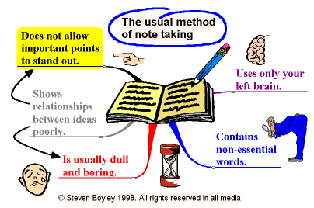

Note Taking Strategies and Skills
If the instructor writes something on the chalkboard/overhead or repeats an idea then it is usually a key point and you should write it down.
Try to use a three-ring binder or a laptop, it allows for more flexibility in rearranging your notes.
Try to sit towards the front and center of the class where you'll be less distracted and can hear the professor the best and have a good angle on any visual aids that may be shown.
Don't rely on someone else's notes, you may not understand everything that they write down and you'll learn the best by taking your own notes.
If your instructor talks fast, it may help to bring an audio recorder and record the lecture while taking notes. After the lecture is over you can replay the lecture and fill in any parts that you missed in your notes.
Do reading assignments or homework questions before class, it is easier to take notes when you know what the instructor is talking about.
Date your notes. Add titles and subtitles when you move onto a new topic for easy referencing.
Write down any terminology along with the definition that the instructor may present.
Make sure that you write legibly, if you can't read them later, they'll be useless. If you have sloppy handwriting it may be wise to type your notes so that they are easier to read.
If you missed what the instructor said, ask them to repeat it or go to the instructor after class and ask for clarification. If you are in a rush, ask the instructor at the beginning of the next class or try to find the answer from a friend or the text.
Compare notes with a classmate to make sure you didn't miss any important points.

